1. **Steps for Adding more volumes to the existing volumes itself 8GB to 15 GB…..**
2. **Created new instance with t2 micro free tier elgible bec its allows 8GB to use so…**
3. **In that existing instance volume as increased 8GB to 15 GB…below images will shown clearly..**

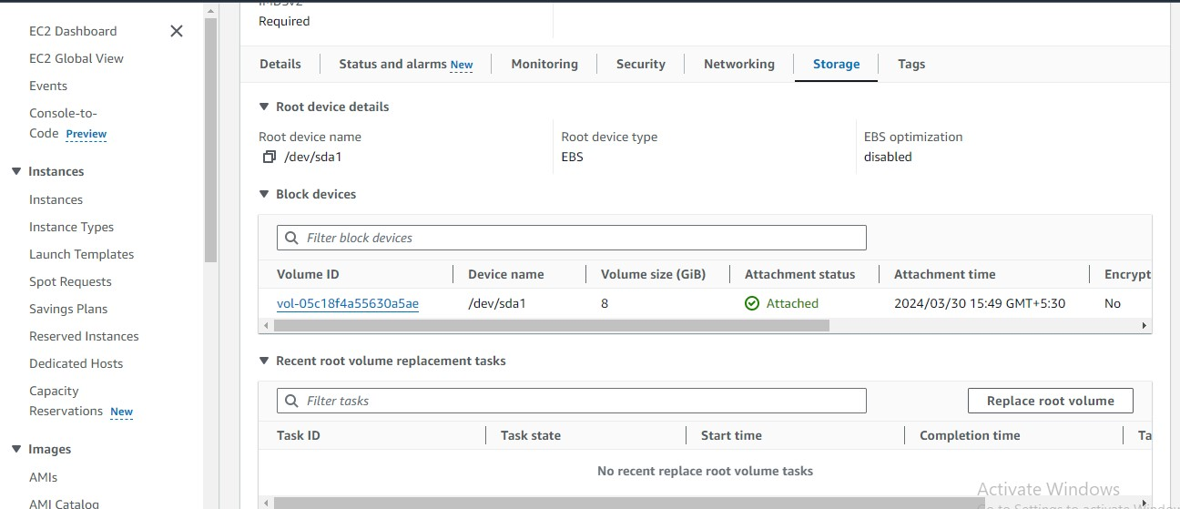

1. **Next go to volumes select that instance and go to actions in that select modify option..**

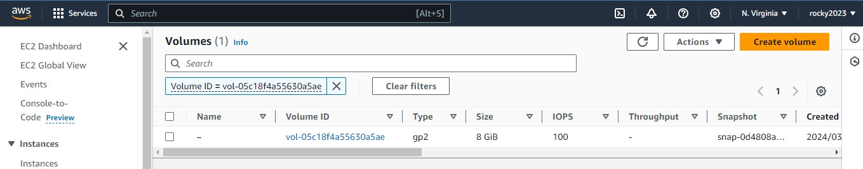

1. **Below image shown the option for modify select and go for modify to increase volumes…**

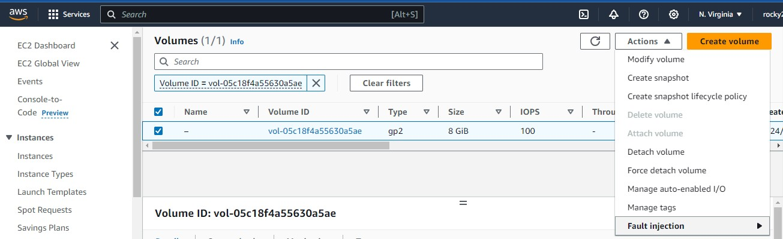

1. **Here below image shown to increase volume…**

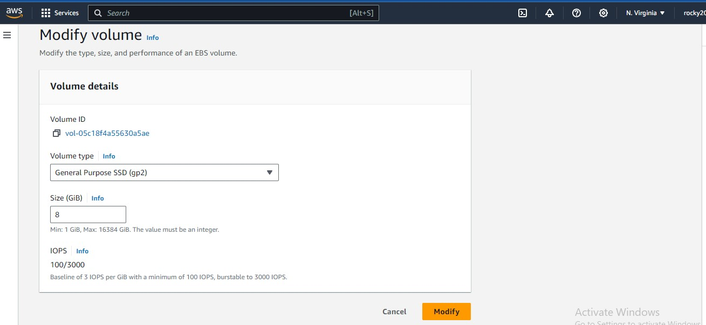

1. **Below image shown that increased volume from 8 GB to 15 Gb…..and next click option modify..**

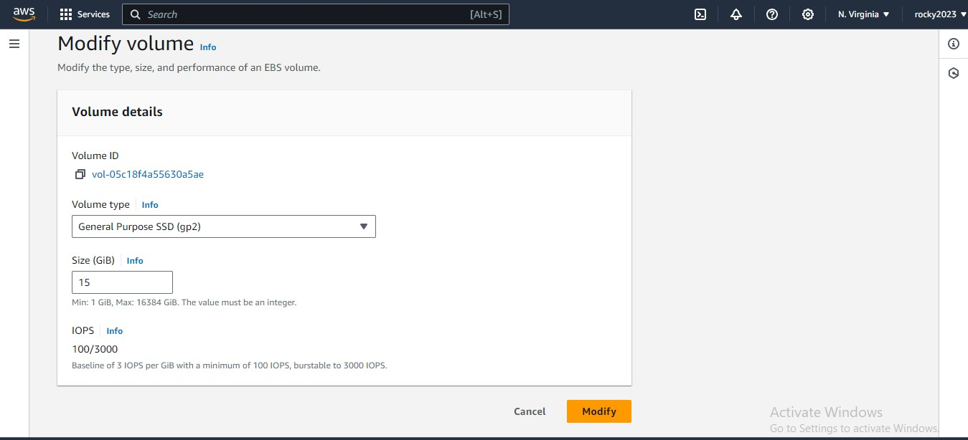

1. **After modify the volume this popup came to give alert about pricing and changing volume …**
2. **So here increase of pricing says so just I stopped here and exit from this..** 